 | Global Federated Identity and Privilege Management:  A Global Concept  Activities and Progress Report  Version 1.0 | 

Global Justice Information Sharing Initiative (Global) Security Working Group (GSWG)
and Security Architecture Committee (GSAC)

November 1, 2006

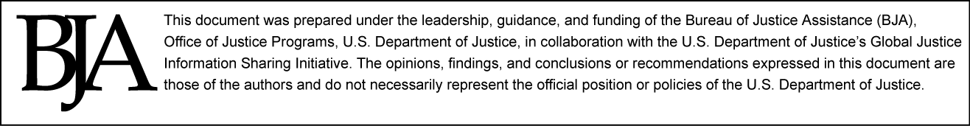

Table of Contents
Overview of the Global Federated Identity and Privilege Management (GFIPM) Essential Components 3
The Global FIPM Metadata (GFIPM-M) and the GFIPM Assertion (GFIPM-A): Development and Testing 3
Metadata for User Assertions 3
Metadata Modeling: Leveraging Global JXDM 3
Uses for Metadata 4
GFIPM-M and GFIPM-A Design Process 5
GFIPM-M /GFIPM—A Process and Timeline 6
The DOJ/DHS GFIPM Demonstration Project 7
Demonstration Overview 8
Federation Participation Premise 8
User-to-Computer Application Connectivity Use Case 8
Project Scope 9
Demonstration Purpose/Objectives 9
Other Objectives Include: 10
GFIPM Demonstration Stages: 10
Stage 1 Overview 11
Stage 2 Overview 11
GFIPM: Stage 2 Progress 14
Demonstration Project Timeline 16
Identity Provider and Service Provider: Development and Testing 17
Pairwise Testing—Participant Results 19
Demonstration Participant Reports and Lessons Learned 19
JNET 19
Number of Participating Users 19
Participating Users 19
Resource Information 20
Participant Statements on GFIPM Concept and Demonstration 20
RISSNET 23
Number of Participating Users 23
Participating Users 23
Resource Information 23
Participant Statements on GFIPM Concept and Demonstration 23
CISAnet 25
Number of Participating Users 25
Participating Users 25
Resource Information 25
Participant Statements on GFIPM Concept and Demonstration 25

Overview of the Global Federated Identity and Privilege Management (GFIPM) Essential Components

At the highest level of concept within the GFIPM model, there are three vital components that must interact between users of multiple systems:

Components | Development Track
Identity Provider (IDP) | DOJ/DHS Demo
Service Provider (SP) | DOJ/DHS Demo
User Profile Assertion (GFIPM Metadata) | GSAC/GSWG

These three major components each represented issues and challenges for configuring and designing the specific requirements for operating and testing the GFIPM concept, or paradigm, within the justice information sharing community.

Although much of the essential work and development of these components was initiated by the Global Security Working Group (GSWG) and performed by the Global Security Architecture Committee (GSAC) with the technical assistance and services of Georgia Tech Research Institute (GTRI), further development, implementation, and testing was conducted within the U.S. Department of Justice (DOJ)/U.S. Department of Homeland Security (DHS) GFIPM Demonstration Project.

The Global FIPM Metadata (GFIPM-M) and the GFIPM Assertion (GFIPM-A): Development and Testing

Metadata for User Assertions
The concept of the common or globally understood metadata across federation systems is the linchpin to GFIPM interoperability. Just as a common Extensible Markup Language (XML) data model was the key to data interoperability, a standard set of XML elements and attributes about a federation user’s identities, privileges, and authentication details can be communicated universally. This common metadata, in the form of an assertion between systems, allows the data owners (service provider) to process and enforce their local policies and technologies for providing security, thereby making independent access and data privacy enforcement decisions about other federation users’ requests for access to specific data or data system resources.

Metadata Modeling: Leveraging Global JXDM
It is only logical, given the work and success of the Global Justice Information Sharing Initiative (Global) Justice XML Data Model (Global JXDM) and National Information Exchange Model (NIEM) data modeling efforts, to leverage and reuse these specifications in describing the GFIPM assertions. The further advantage of the NIEM specification is that it inherently makes the model immediately more applicable to other domains and systems, rather than focused on criminal justice users and systems. The design requirements for the GFIPM assertion include 1) identifying the attributes needed to support the use cases for interoperable federated identity and privilege management;
2) identifying the standard technology and representation for these attributes; and
3) defining the “assertions” structure for the technology employed.

Uses for Metadata
There have been four major purposes, or use cases, supported by the design decisions of the GFIPM Metadata and Assertion process:
  - Identification/Authentication—Those attributes needed to communicate identification of end users and the associated authentication context. Who is the end user, and how did they authenticate?
  - Privilege Management—Those attributes captured by identity providers (IDPs) which can assist service providers (SPs) in making authorization decisions. What certifications, clearances, job functions, local privileges, and organizational affiliations are associated with the end user that can serve as the basis for authorization decisions?
  - Audit—Those attributes needed or required for the purposes of auditing systems, system access, use, and legal compliance of data practices.
  - Personalization—Those attributes that can enable local systems to feature specialized services, regionalization, or special interest characteristics of their local software (e.g., regional news or alerts, special interest group (SIG) information, display, and tool settings or preferences).

GFIPM-M and GFIPM-A Design Process

The development process for the GFIPM assertion has been based on a limited scope. The primary focus has been on the collection of attributes (metadata) required to support the GFIPM use cases and specify federated users and federated entities in accordance with known and applicable industry standards. The scope was initially limited to responses provided by GSAC survey participants.

The first level of development was the identification and collection of metadata,
GFIPM-M, based on the survey results of GSAC members and the systems that they represent. This initial set of metadata was grouped and harmonized among the independent responses and then mapped to NIEM 0.3 as the base vocabulary. This resulted in a straw man set of metadata, which was then vetted back with the entire GSAC, a separate GSAC GFIPM tiger team, and the DOJ/DHS GFIPM demonstration project participants. This resulted in the GFIPM-M 0.2 package that is being used by the demonstration project today. Lessons learned from this project to date have been captured and incorporated into the GFIPM-M 0.3 package, which is the current version and provides the basis for further development and expanded vetting.

The next level of the development process seeks to build this metadata set into the form of a technology standardized assertion format, which will result in the Global Federated Identity and Privilege Management Assertion (GFIPM-A). Several different techniques for encoding this metadata into Security Assertion Markup Language (SAML) assertions have been identified and documented as part of the GFIPM-M 0.3 package. Lessons learned from the demonstration project and feedback from the broader community will lead to a specific recommendation and standard for the GFIPM-A.

The distinction of the attributes available within GFIPM-M is specific to the requirements for describing either a user or a federation entity. In other words, the GFIPM-M supports both the necessary attributes for system-to-system, system-to-user, and/or user-to-user contexts for information sharing. The profile or use cases of creating either a federation entity assertion or a user assertion are subsetted within the GFIPM-M. Separately, the GFIPM-A specification will detail the attributes and requirements for SAML encoding, binding, and assertion transport for either assertion use case. However, beyond the context of GFIPM-M, it should be noted that a comprehensive collection of all security metadata requirements required for the justice or national information sharing community, including privacy, Service-Oriented Architecture (SOA), networking, other layers of the security stack, and a comprehensive security process were considered outside the scope of this initial survey and draft specifications.

GFIPM-M/GFIPM—A Process and Timeline

Process | Description | Status/Due
Call for Data Requirements | An initial set of data requirements was solicited from the Global Security Architecture Committee participants via a simple set of questions. Many of the GSAC participants represent systems and networks with embedded identity and privilege management requirements in operation today. | Done  Aug 2005
Collect and Compile Survey Results | Place submissions in a consistent machine-readable format for manipulation and analysis. | Done  Sept 2005
Validate Data Requirement Submissions for Completeness and Clarity | - Ensure that all submitted data requirements are associated with unambiguous, semantically precise definitions.  - Determine representation and content for each data requirement (e.g., numeric, text, code). NIEM core representation types provided the basis for typing data components. | Done  Oct 2005
Supplement With Attributes From Applicable Standards as Required | The following standards will be considered for the extraction of data requirements:  - Security Assertion Markup Language (SAML) 2.0 series of specifications.  - Liberty Alliance ID-SIS 1.0 series of specifications.  - Liberty Alliance ID-FF 2.0 series of specifications.  - Internet Engineering Task Force (IETF) - inetOrgPerson (RFC 2798) derived from X.521 person and organizationalPerson with additional attributes. | Done  Oct 2005
Logically Group Attributes Into Categories | Analysis of the submitted data requirements will ultimately determine the categorization and aggregation of attributes. | Done  Nov 2005
Develop Straw Man | A straw man was developed from the superset of candidate attributes from survey submissions and applicable standards for each of the categories defined above. | Done  Dec 2005
Vet and Refine Straw Man | - The initial vetting of the straw man was through the Global Security Architecture Committee members. Survey participants validated mappings between their submissions and the resultant straw man for semantic consistency.  - Feedback was solicited and incorporated. The straw man was updated and provided as a recommendation by GSAC for review and vetting to a broader Global community. | Done  Jan 2006
Harmonize With Current  Version of GJXDM/NIEM | - Once consensus has been reached on the data requirements, semantics, and representation of the GFIPM Security Assertion, it will be semantically and structurally harmonized with the current version of the Global JXDM. Attributes that are currently in the Global JXDM will be mapped, while new data requirements will be submitted for inclusion in a future version of the Global JXDM. This will be an ongoing activity until the convergence and stabilization of NIEM and Global JXDM.  - Data requirements and associated attributes derived from existing standards (SAML) will be referenced in the GFIPM Assertion for completeness but not duplicated in the Global JXDM. | Ongoing  Through April 2007 (NIEM 1.1)  Initial:  Feb 2006

Process | Description | Status/Due
Advanced Vetting of the GFIPM Metadata | - A GSAC representative Tiger Team was established for continued vetting and design process of the GFIPM metadata and assertion specification development. An initial vetting session was conducted in March 2006.  - Broader vetting of the GFIPM-M is required prior to making a full recommendation for implementation. The GSWG and Global community will continue to serve as the vehicle for this expanded vetting of GFIPM-M. | Ongoing  Through 2006  Initial: March 2006
Incorporate Feedback and Iteratively Refine and Publish “Draft” GFIPM Metadata Packages | - GFIPM-M was published in a separate document along with a NIEM representation. This corresponded to the GFIPM-M 0.2 distribution package.  - Based on feedback from the vetting process and lessons learned from the DHS/DOJ demonstration process, additional versions of the GFIPM-M package will be published. The current version of GFIPM-M is the 0.3 version. | Ongoing  Through 2006  Initial:  April 2006
Develop and Vet GFIPM-A Specification | - A set of alternatives for encoding GFIPM-M in SAML along with pros and cons have been identified and documented. This is included as a separate document as part of the GFIPM-M 0.3 package.  - The demonstration project participants have reviewed and deliberated on these alternatives and selected one of these alternatives for use in the demonstration project. Lessons learned will be captured from the demonstration project leading to further specification and recommendations for the GFIPM-A.  - Additionally, specific encoding techniques have implications with regard to commercial off-the-shelf (COTS) product support. Some limited COTS testing is being conducted as part of the demonstration product. Lessons learned will be captured and provided to GSAC/GSWG for consideration. | Ongoing  Through April 2007  Initial:  September 2006

The DOJ/DHS GFIPM Demonstration Project

The concept of a federation has emerged from the Global Security Architecture Committee and has received growing interest from several local, state, regional, and federal systems. As a result, a demonstration project was initiated under the cosponsorship of the U.S. Department of Justice (DOJ) and the U.S. Department of Homeland Security (DHS). The initial phase of this proof of concept included participation from the Criminal Information Sharing Alliance network (CISAnet), Pennsylvania Justice network (JNET), and the Regional Information Sharing Systems® (RISS) network (RISSNET™). Others expressing interest in participating in the demonstration during follow-on phases include the California Department of Justice, Wisconsin Department of Justice, DHS’s Homeland Security Information Network (HSIN)/Joint Regional Information Exchange System (JRIES), and the Automated Regional Justice Information System (ARJIS). The data requirements and the resultant set of vetted attributes identified through this survey process will be validated operationally as part of the GFIPM demonstration project.

Demonstration Overview
Use of standard agreements, industry standards, and open standards-compliant technologies make identity and entitlements portable across autonomous domains, organization to organization, organization to individual, or individual to individual. Once an identity provider has authenticated a user, that individual can be recognized easily and take part in the services offered by other federation service providers. Based on trust and standards, federated versus centralized identity management offers a scalable alternative to address the interdomain security challenge.
Federation Participation Premise
  - Federation participants retain control over their resources, applications, and databases. Dissemination and access control decisions are made locally.
  - Each federation participant registers with a certified identity provider and administers their subscriber base.
  - Federation participants can implement local technologies and mechanisms.
  - All federation participants agree to a minimal set of policies, procedures, and standards, allowing for subscriber authentication and privilege information to be passed between participants in a manner that is trusted and well-known.
  - Federation participation in the federation does not preclude independent out-of-band bilateral agreements between participants.

Three distinct use-case scenarios have been identified by the Global Security Architecture Committee as applicable to information sharing between local, state, regional, tribal, and federal agencies: 1) system-to-system connectivity, 2) user-to-application connectivity, and 3) user-to-user/system-to-user messaging. Although each use-case scenario is pertinent and must eventually be addressed, the user-to-application connectivity use-case scenario was the focus of the demonstration project to keep the scope of the project manageable.
User-to-Computer Application Connectivity Use Case
Essentially, User A of System A needs to connect to the application resources offered by System B, begging the question, How do applications made accessible by System B identify, authenticate, authorize, entitle, and ultimately trust users of System A? Although the answer will differ based on the particular system and application, the initial demonstration use-case scenario will be to facilitate secure, authenticated access to static Web content that requires the identification and authentication of a group, role, or sponsoring system to which a given user belongs. Characteristics of the user-to-application identity and authentication use case include the following:
  - A valid subscriber of System A can access a Web-based application of System B, a federation participant.
  - A valid subscriber of System B can access a Web-based application of System A, a federation participant.
  - A subscriber registers locally and is not required to reregister to another federation participant’s system or application. Registration is completed when an individual user is vetted and assigned an electronic credential.
  - A subscriber authenticates locally and is not required to reauthenticate to another federation application, even if the subscriber has traversed multiple applications within the federation.
  - Subscriber information in the form of an agreed-upon set of attributes is passed to the system or application such that access control decisions can be made without local provisioning. Provisioning is the act of setting up a user account that allows a registered user access to local system resources.

Project Scope
The scope of the demonstration project was to develop and prove an identity and privilege management service that can be used to apply authentication and access controls by disparate systems and networks desiring to make their resources sharable. The outcome was intended to demonstrate a universal mechanism, implementation-independent, and nonvendor-specific, designed to share trusted assertions in the form of an agreed set of attributes that can be used to apply authentication and access controls.
The demonstration was limited to:
  - The user-to-computer application use case.
  - Web-based applications only.
  - JNET, CISAnet, and RISSNET to prove the concept.
  - Open-source, noncommercial software to keep the software licensing costs to a minimum.

Demonstration Purpose/Objectives
The focus of the demonstration project was to 1) achieve a quick win, 2) capture lessons learned, and 3) lay a foundation of experience on which participants, stakeholders, and sponsors can assess the value and feasibility of a security and information sharing architecture based on federated identity and privilege management. The intent was to demonstrate a real-life multidirectional, electronic exchange of criminal intelligence information, achieved through secure interoperability between networks and information systems currently not capable of doing so.

Other Objectives Include:
- Demonstrate that registered subscribers of one federation participant can access the Web-based resources of another federation participant without the requirement to register with more than one federation participant.
- Demonstrate that federation participants can retain control over their resources, applications, and databases and make local dissemination and access control decisions based on a shared set of standard subscriber attributes.
- Demonstrate single sign-on across federation Web applications.
- Demonstrate federated authentication and authorization between disparate local technologies and vendor implementation.
- Establish a baseline of common attributes for identity and authorization assertions.
- Provide an open-source free version of the GFIPM infrastructure available to the community and vendors for the implementation of Identify Providers and Service Providers.
GFIPM Demonstration Stages
The GFIPM federation deployment schedule contains four distinct deployment stages. Each of these stages is listed and described below.
Stage | Goals
1 | Basic Infrastructure Deployment With the Shibboleth 1.3  Open Source Implementation of SAML 1.1
2 | Implementation of Live Systems Within the Infrastructure
3 | Migration to Shibboleth 2.0 / SAML 2.0
4 | Interoperability Testing With COTS SAML 2.0 Products

NOTE: Stages 1 and 2 described here correspond to Phase II and Phase III of the project as described below. Stage 3 and 4 above were originally outside the scope of the demonstration project but have been included based on the desires of the project participants and will be addressed as part of the demonstration project as time and funding permit.

Stage 1 Overview
During Stage 1, each participant will set up the basic Shibboleth infrastructure on local hardware. There are two Shibboleth components that each participant must set up: an Identity Provider (IDP) and a Service Provider (SP). At the end of Stage 1, the federation will be operational in the sense that each participant's IDP will be able to interface properly with each SP in the federation, and each participant's SP will be able to interface properly with each IDP in the federation. Each participant must choose an operating system platform for the IDP and SP during Stage 1. The choices are Microsoft Windows 2003 and Red Hat Enterprise Linux (RHEL). Links to platform-specific instructions for setting up an IDP and an SP on each platform are located below, as well as at the navigation pane on the left side of the page.

Stage 2 Overview
During Stage 2, each participant will transform their basic Shibboleth infrastructure components from Stage 1 demo components into live, working Identity Provider and Service Provider systems that provide federated access to live information resources for actual users. There are three basic tasks that participants must complete during Stage 2:

1. Live SSO System Integration—Replace the Stage 1 demo user name and password Single Sign-On (SSO) authentication system with a production-quality SSO system that can authenticate actual users.
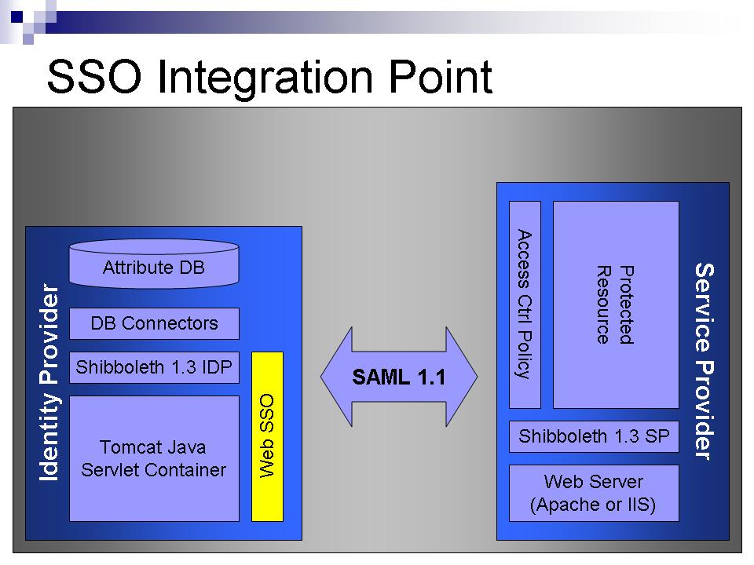

2. Live Attribute Repository Integration—Replace the Stage 1 demo attribute connectors with software that connects to a live attribute repository, and a Limited Directory Access Protocol (LDAP) repository queries the repository for the appropriate attributes and transforms the results into a format that is compliant with the GFIPM User Assertion 0.2.
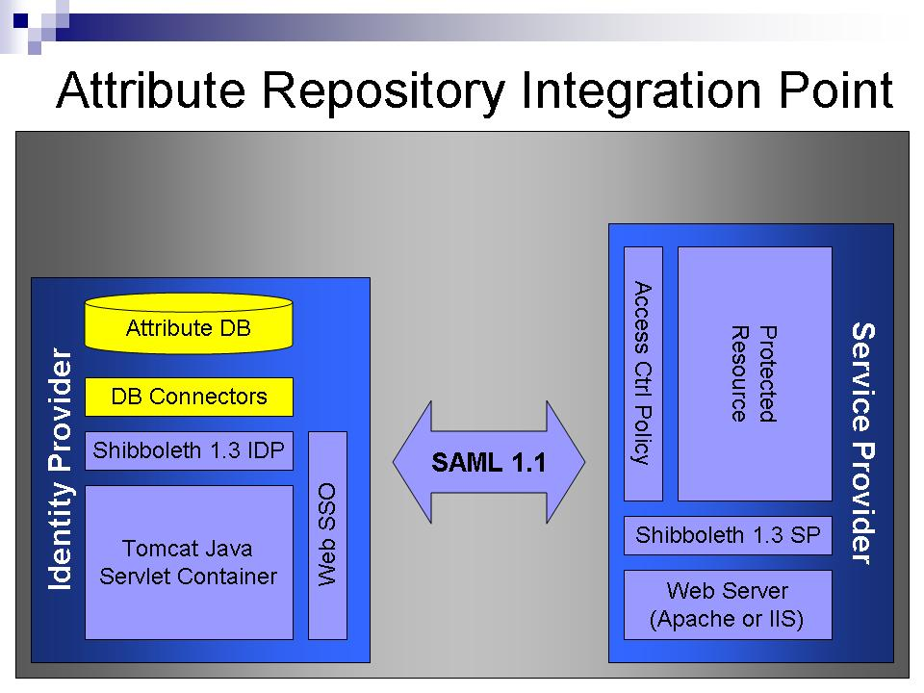

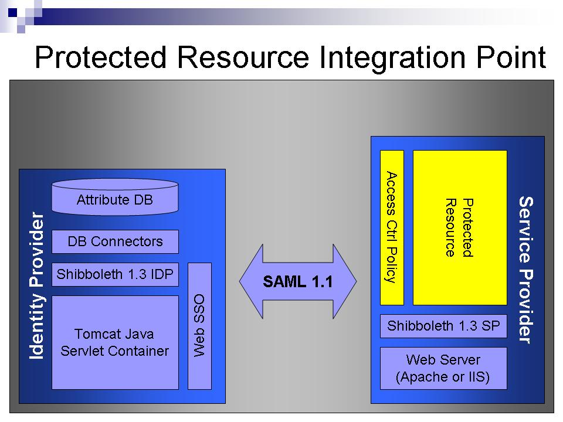
3. Live-Protected Resource Integration—Replace the Stage 1 demo-protected resource with a live application or resource that provides useful information to federated users and incorporates appropriate access control logic based on information received from identity providers via GFIPM User Assertion Demo Profile Instances.

In support of these tasks, GTRI has created the following tools and documentation items.
- GFIPM Assertion 0.2 Package
This package contains the formal specification for the GFIPM User Assertion, Version 0.2, and the GFIPM Entity Assertion, Version 0.2. It specifies the assertions at two logical levels: the reference model level, which is optional and over-inclusive, and the demonstration profile level. The reference model, sometimes called the conceptual model, is specified via a Microsoft Word document and a Microsoft Excel spreadsheet. The demonstration profile is specified by a Microsoft Excel spreadsheet and an XML schema.
- Instructions for Configuring Tomcat X.509 Client Certificate Authentication
These instructions describe how to configure the Tomcat Web servlet container to perform client certificate authentication using X.509 client certificates.
- Stage 2 Configuration Instructions for a Shibboleth Service Provider
These instructions describe how to configure a Shibboleth Service Provider (SP) to consume a GFIPM User Assertion Demo Profile Instance.
- Attribute File Streamer Connector
The Attribute File Streamer Connector is a custom attribute repository connector for a Shibboleth Identity Provider (IDP). When used in an IDP, it can cause the IDP to transmit the contents of a specified text file on the local file system as the value for a specified SAML attribute within a SAML attribute assertion. Available are a zip file with the Attribute File Streamer Connector code, a sample GFIPM User Assertion Demo Profile Instance, and instructions for deployment and use.
- GFIPM User Assertion LDAP Connector
The GFIPM User Assertion LDAP Connector is a custom attribute repository connector for a Shibboleth Identity Provider (IDP). When used in an IDP, it can connect to an LDAP data repository, query the LDAP repository for necessary attributes, transform the LDAP attributes into a form that constitutes a GFIPM User Assertion Demo Profile Instance, and hand the result off to Shibboleth for transmission as an SAML attribute value within an SAML attribute assertion.
- Stage 2 Reference Identity Provider
This Identity Provider (IDP) can interoperate with a Service Provider (SP) and generate several different profile instances, so that developers can verify the SP's ability to receive each instance and restrict access according to an appropriate policy.
Finally, to help GFIPM participants test their Stage 2 systems, the GTRI is developing a reference service provider.
Stage 2 Reference Service Provider—This is a Service Provider (SP) that can interoperate with an Identity Provider (IDP) and perform several types of validation for the profile instances that the IDP sends to it. The first type of validation is to verify that the profile instance is compliant with the demo profile schema. The second type of validation is to verify that the profile instance contains all of the elements that have been marked as mandatory for the demo profile. The third type of validation is to analyze the data in the profile instance and generate a report describing which protected resources would be available at each participant's SP for a user with this profile instance.

GFIPM: Stage 2 Progress
Stage 2 of the GFIPM deployment cycle involved each participant integrating Shibboleth with their existing services. For Identity Providers, this meant integrating Shibboleth with their existing log-in/single sign-on system, as well as integrating their LDAP attribute repositories with Shibboleth via the GFIPM Custom Data Connector. For Service Providers, this meant consuming a GFIPM User Assertion and performing access control based on its contents for a given service (or set of services).

During Stage 1, it was easy to declare the systems that are working by third-party inspection, but the current IDPs are only accessible to personnel from each organization, so each organization must verify independently that their IDPs are working. Additionally, each organization is unable to verify that their SPs work with each IDP in turn, as they can test only against their own IDP and, in some cases, the Reference IDP. In many cases, the Reference IDP will be correctly denied access to sensitive services, making it an ineffectual test tool.

CISA
Authentication Integration Point | CISA is using Client Certificate Authentication based on certificates issued to CISAnet members for use with their current network. This authentication is functional.
Attribute Repository  Integration Point | CISA is using an LDAP repository filled with user attributes. It is using the GFIPM User Assertion LDAP Connector v 1.0.1 to generate GFIPM User Assertions based on the contents of their LDAP database. The generated user assertions have been tested with the GFIPM Stage 2 Reference Service Provider.
Services Provided | CISA is currently planning on making all services specified on their participant overview available.  - Arizona Counter-Terrorism Information Center—Unavailable  - Arizona Sex Offender Information Center—Unavailable  - Arizona Department of Public Safety GANGNET—Unavailable  - CISAnet Federated Query Tool (CFQT)—Unavailable  - Georgia Bureau of Investigation Sex Offender Registry—Unavailable  - Oklahoma State Bureau of Investigation Officer Safety Bulletin—Unavailable  - Texas Criminal Law Enforcement Online (CLEO)—Unavailable

JNET
Authentication  Integration Point | JNET is using Client Certificate Authentication based on certificates issued to JNET members. This authentication is functional.
Attribute Repository  Integration Point | JNET is using an LDAP repository filled with user attributes. It is using the GFIPM User Assertion LDAP Connector v 1.0.1 to generate GFIPM User Assertions based on the contents of their LDAP database.
Services Provided | JNET is currently planning on making some subset of the services specified in their participant overview available. Many of these services are pending the permission of the organization that owns the resource.  - Pennsylvania Driver's License Photos—Pending Organizational Permission  - Pennsylvania Department of Corrections Intake/Exit Photos—Pending Organizational Permission  - Pennsylvania Probation "Fail to Report" Photos and Cases—Available—JNET reports this as operational for JNET and soon for RISS/CISA.  Requires: Government Data Search Privileges.  - Pennsylvania State Prisoner Locator—Pending Organizational Permission  - Pennsylvania Criminal Trial Case Information—Pending Organizational Permission  - Pennsylvania Arrest Warrants Outstanding for Failure to Pay Child Support—Pending Organizational Permission  - White Pages of Pennsylvania Justice Staff—Pending Organizational Permission  - Pennsylvania Amber Alert—Pending Organizational Permission

RISS
Authentication  Integration Point | RISS is using Client Certificate Authentication on their IDP.
Attribute Repository  Integration Point | RISS is using an Active Directory repository filled with user attributes. It is using the GFIPM User Assertion LDAP Connector v 1.0.1 to generate GFIPM User Assertions based on the contents of their Active Directory (Active Directory supports the LDAP protocol).  RISS will consider updating with what attributes they populate a GFIPM User Assertion as time moves forward. For the moment, it is complete.
Services Provided | RISS is currently planning on making all services specified on their participant overview available:  - HSIN Counterterrorism Briefs, Reports, and Documents—Available  Requires: Federation Log-In.  - RISS Counterterrorism Briefs, Reports, and Documents—Available  Requires: Sworn Law Enforcement Officer and 28 CFR Part 23 Training.

Demonstration Project Timeline

Phase I | Project Initiation (15 Oct–15 Dec)
Phase I | - Develop demonstration scenario  - Technical requirement establishment  - Develop GFIPM attribute data dictionary
Phase II | GFIPM Infrastructure Establishment (1 Jan–30 Apr)
Phase II | - Middleware implementation  - Test-bed establishment  - Develop IDP/SP Interface Specification/Integration Guide
Phase III | IDP/SP Development and Integration (1 May–1 Oct)
Phase III | - CISA IDP and SP interface development  - JNET IDP and SP interface development  - RISS IDP and SP interface development  - Provide technical assistance to IDP/SP interface developers  - Integration and testing
Phase IV | Demonstration, Evaluation, and Assessment (1 Nov–5 Jan)
Phase IV | - Conduct demonstrations for stakeholder and funding agencies  - Collect feedback and lessons learned  - Incorporate refinements as appropriate  - Identify next steps  - Develop final report

Identity Provider and Service Provider: Development and Testing
Two essential GFIPM components are the Identity Provider mechanism and the Service Provider mechanism. These are specifically configured servers dedicated to the functions of interacting with other federation requests for Identity and Authentication details (IDP) and for authorizing services and resources (SP).

The GFIPM approach to privilege management is based on a set of well-defined attributes (metadata) associated with an authenticated subject (person or application process) that is passed between Identity Providers (IDPs) and Service Providers (SPs) using trusted security (SAML) assertions. Service Providers provide business logic, which can implement their access control policy down to the user level, based on a trusted set of attributes provided with the request for information or service. There is no requirement for access control policies or the set of attributes required to be consistent across the entire federation. SPs ultimately have the final access control decision and may regulate access based on the IDP or set of attributes provided. However, some minimal supported set of standard attributes and general guidelines for what is expected for access to different types of information should be provided.

IDPs are responsible for authenticating their subscribers and constructing security (SAML) attribute assertions based on information that they either collect and maintain directly or that they have access to via a trusted relationship with one or more attribute authorities. In providing the essential constructs of these components, the GFIPM Project sought to develop and test a prototype of both the IDP and the SP mechanisms and further sought to develop these in open-source software as reference implementations that could be reused and reconfigured by the Global justice practitioner community.

For the process of development and testing these concepts, a set of objectives and implementation parameters were considered, including, but not limited to, the following:

  - Demonstrate a working single sign-on function in a GFIPM system.
  - Demonstrate a working single sign-off, also known as a global log-out function, in a GFIPM system.
  - Demonstrate the ability of a GFIPM Service Provider to enforce access control policies on federated users.
  - Demonstrate that both the GFIPM IDP and SP models can interoperate with all of the demonstration participants (CISAnet, RISSNET, and JNET) without modification or, alternatively, implement the modifications required to achieve such interoperability.
  - For commercial security products, demonstrate SAML protocol-level interoperability between the open-source-based SAML (Shibboleth) and an identity provider using test COTS products or, alternatively, determine exactly why the product is incompatible.
  - Demonstrate GFIPM components with common operating systems and directories: Windows XP, Linux Red Hat, and LDAP.
  - Evaluate and determine which Security Assertion format best fits the GFIPM strategy/architecture in terms of performance, interoperability, security, and operational efficiency.
  - Identify, document, and develop the necessary tools and scripts for installation, configuration, and life-cycle management of the federation middleware, SAML, and open-source components.
  - Demonstrate the scalability of a GFIPM-based federation.
  - Provide technical input necessary for the development of policies and procedures for adding new member organizations to a GFIPM-based federation and removing member organizations from the federation.
  - Provide technical input necessary for the development of policies and procedures for the initial deployment and subsequent management of a PKI solution to support the cryptographic requirements and needs of a GFIPM-based federation.
  - Demonstrate the reusability of all custom software tools developed for a GFIPM-based federation as part of this demo.

Pairwise Testing—Participant Results
Service Provider | Identity Provider | Authenticate | Redirect | Attributes and Backchannel
GTRI Reference
 | RISS | yes | yes | yes
 | CISA | yes | yes | yes
 | JNET | yes | yes | yes
RISS
 | GTRI Reference | yes | yes | yes
 | RISS | yes | yes | yes
 | CISA | yes | yes | yes
 | JNET | yes | yes | yes
CISA
 | GTRI Reference | yes | yes | firewall issues*
 | RISS | yes | yes | firewall issues*
 | CISA | yes | yes | yes
 | JNET | yes | yes | firewall issues*
JNET
 | GTRI Reference | yes | yes | yes
 | RISS | yes | yes | yes
 | CISA | yes | yes | yes
 | JNET | yes | yes | yes

* Tested with firewall temporarily disabled and everything worked.
All tests were performed from within a GTRI subnet. This may have impacted the results of any tests above in which special firewall rules apply to this network.

Demonstration Participant Reports and Lessons Learned
JNET

Number of Participating Users
Approximately 50 users from JNET will have access to GFIPM resources.

Participating Users
JNET users of GFIPM resources will consist of the following user types:
  - Adult Probation Supervisors
  - Chiefs of Police
  - District Attorney Office Staff Members
  - Domestic Relations Officers
  - Emergency Management Chiefs
  - Lieutenants/Sergeants/Detectives
  - Police Officers
  - Probation Officers
  - TAC Officers

Resource Information
The following JNET resources are available to GFIPM users:
  - Pennsylvania Driver's License Photos
  - Pennsylvania Department of Corrections Intake/Exit Photos
  - Pennsylvania Probation “Fail to Report” Photos and Cases
  - Pennsylvania State Prisoner Locator
  - Pennsylvania Criminal Trial Case Information
  - Pennsylvania Arrest Warrants Outstanding for Failure to Pay Child Support
  - White Pages of Pennsylvania Justice Staff
  - Pennsylvania Amber Alert

Note: Availability of the above JNET resources is currently pending approval by the appropriate data owners and policymakers within the JNET governance bodies.

Participant Statements on GFIPM Concept and Demonstration
JNET and the Federated Identity and Privilege Management Concept

- The value of the GFIPM concept to JNET and the JNET community.

  - The GFIPM concept of trusting a federation member agency’s own registration system to provide the most accurate and current identity and home privilege information on a user is unquestionably the most reasonable approach to take if data sharing among agencies is to be done at a national level. No amount of due diligence by an external agency can replace the diligence of the agencies closest to those requesting the data. To date, the experience of the GFIPM pilot demonstrates the approach of relaying identity and home privilege information to a federation service provider has been shown to be viable, reliable, and secure. In addition, this approach has also demonstrated its value in the international college and university community, which has been using Shibboleth for some time.

The value of this concept to the JNET community is elimination of the redundant registration process for federation member agencies and the elimination of expensive and cumbersome VPNs, remote user gateways, and closed intranets by using the public Internet and FIPS 140-2-compliant security instead. The savings will be a direct-dollar reduction in costs and a reduction in costs associated with time saved by practitioners, given the reduction in the complexity involved in obtaining information from member agencies within the federation. Quickly sharing this type of information will allow our participants to be far more effective.

  - Use of the public Internet will also expand the number of mobile users because their home agencies will not have to install mobile to intranet gateways.

- The most promising aspects of GFIPM for information sharing with users outside JNET are as follows:

  - The ease with which new users can begin accessing JNET resources without reregistration or can access role decisionmaking by each individual user.

  - That JNET service provider agencies will still set the criteria, now expressed as the requirements for specific GFIPM User Assertions, to protect their content.

- Lessons learned during system setup, development, and unit testing.

  - Because every federation member must map at least some questionable data from legacy identity management systems, JNET found it necessary to explain to the end user how JNET interpreted their home privileges and how it impacted their JNET privileges. The end user is then required to digitally reaffirm their identity and confirm that their home privileges are correct. The resulting signature act, upon risk of false swearing and forgery, is sufficient for JNET member agencies to trust the end-users’ assertions.

  - Existing user enrollment and registration systems in most justice environments should be upgraded to full identity and privilege management systems, the result being the Identity Provider function can create more reliable user assertions for the members served.

- JNET believes that the GFIPM approach is feasible for achieving interoperable security between Global justice information sharing partners. The Identity Provider/Service Provider architecture is proven and more than adequate to enable information sharing based on exchange of User Assertions.

- Implementing GFIPM beyond RISS, JNET, and CISAnet.

  - The amount of configuration and integration with legacy identity systems should not be minimized. Nonetheless, the legacy systems are currently protecting the users’ home resources and should be used for expanding GFIPM rather than waiting for a future unspecified, perfect identity-management standard. As the new systems and standards are implemented, they can be phased into a GFIPM type system with simple style sheet changes without impact to end users or established information sharing. End users would be unaware of any changes other than those required by their home agency.

- Continued support of the GFIPM concept.

  - JNET encourages the additional work needed to package components of GFIPM for easy implementation, preparation of sample configuration files, and reworking of the User Assertions based on lessons learned during the live GFIPM demonstration pilot. JNET also encourages an expanded pilot with additional federation members as well as expanded content offerings from existing federation members.

JNET believes the concept is sound and should be supported by Global for continued development and implementation.

RISSNET

Number of Participating Users
Approximately five users from RISS will have access to GFIPM resources.

Participating Users
RISS users of GFIPM resources will consist of the following user types:
  - Intelligence Analysts
  - Intelligence Technicians
  - Law Enforcement Officers

Resource Information
The following RISS resources are available to GFIPM users:
  - Reports, briefs, and documents related to counter-terrorism that are provided by the U.S. Department of Homeland Security via the Homeland Security Information Network (HSIN).
  - Reports, briefs, and documents related to counter-terrorism that are provided by RISS.

Participant Statements on GFIPM Concept and Demonstration
Value of the Federated Identity Model for Expanding Information Sharing Capabilities
Note: This document was prepared in response to a request by John Wandelt, Project Manager of the Global Federated Identity and Privilege Management (GFIPM) Demonstration Project, and is intended to be used as input for his presentation to the Global Security Working Group (GSWG) and the Global Security Architecture Committee (GSAC) at the September 2006 meeting of those groups.

Federated Identity Management is defined as: “the agreements, standards, and technologies that make identity and entitlements portable across autonomous
domains.” RISS considers the Federated Identity Management model as the most appropriate approach to sharing information with its autonomous partners. The Federated Identity Management model will allow partners in an information sharing federation to employ a variety of user identification and access control credentials by encapsulating the vital content of each type of credential, along with other related information, into an industry standard Extensible Markup Language (XML) construct called an assertion.
The structure of the assertion will conform to the standards established by the Organization for the Advancement of Structured Information Standards (OASIS) as represented in their Security Assertion Markup Language (SAML) authentication protocol.

The participation of RISS in the Global Federated Identity and Privilege Management (GFIPM) Demonstration Project is based on its belief in the Federated Identity Management concept as a foundation for securely sharing criminal justice and law enforcement sensitive information across a very broad range of agencies at all levels of government. RISS’s experience in GFIPM to this point in the project has added to Global’s confidence in the Federated Identity Management approach. It has also provided valuable lessons that will help in future information sharing endeavors. Of greatest value, perhaps, is the work done on the metadata that can be used to identify a user who has been authenticated to their home system in such a way as to allow RISS, acting in its service provider role, to make a reasonable decision about which of the RISS resources others are permitted to access. Experience gained working with federation partners to reach agreement on the complex metadata will also be of great benefit in future federation endeavors.

CISAnet

Number of Participating Users

For the GFIPM Demonstration, CISAnet participants will have ten law enforcement personnel consisting of sworn officers and intelligence analysts per state accessing JNET and RISS available resources, for a total of 100 users.

Participating Users
All CISAnet users of GFIPM resources are either sworn officers or intelligence analysts for one of the following CISAnet participant agencies:
  - Alabama Bureau of Investigation
  - Arizona Department of Public Safety
  - California Department of Justice
  - Georgia Bureau of Investigation
  - Idaho State Police
  - Louisiana State Police
  - Mississippi Department of Public Safety
  - New Mexico Department of Public Safety
  - Oklahoma State Bureau of Investigation
  - Texas Department of Public Safety

Resource Information
The following CISAnet resources are available to GFIPM users:
  - Arizona Counter-Terrorism Information Center (ACTIC)
  - Arizona Sex Offender Information Center
  - Arizona Department of Public Safety GANGNET
  - CISAnet Federated Query Tool (CFQT)
  - Georgia Bureau of Investigation Sex Offender Registry
  - Oklahoma State Bureau of Investigation Officer Safety Bulletin
  - Texas Criminal Law Enforcement Online (CLEO)

Participant Statements on GFIPM Concept and Demonstration
As acknowledged during fall of 2005, there are many nationally recognized sensitive but unclassified (SBU) networks that support substantial investments in technology and trust relationships that are not interoperable. A major obstacle to this secure information exchange and interoperability is that of identity and privilege management. As is the case with many of these networks, CISAnet users would have to subscribe to multiple registration processes and manage multiple security mechanisms and passwords to get access to all the resources they need. With an increasing demand for secure information sharing between local, state, and federal agencies, this approach is unmanageable, frustrating to users, and will not scale to meet the larger information sharing vision.

The Global Federation Identity and Privilege Management (GFIPM) project provides a standardized means for allowing agencies to directly provide services for trusted users that they do not directly manage. The GFIPM project demonstrates that the identities from three different enterprise domains, CISAnet, JNET, and RISS, can be granted access to the services of other enterprises. Although this demonstration project is still in its early phases, the successes can already be seen.

CISAnet participants agree with the basic GFIPM premise that:

- Individual programs can and should vet their own subscriber base. CISAnet participating agencies perform this function to the best of their ability and have direct responsibility for managing their intrastate users. This concept also allows effective off-loading of user administration costs back to the provider.

- Those vetted subscribers are trusted users across the enterprise. The user experience is improved because users can navigate easily between resources while maintaining a global log-in identity. Authorized individuals have access to the resources they need regardless of where they reside.

- The service providers, CISAnet state agencies, are ultimately responsible for what information is provided. The federated model enables service providers to share and control resources to a large base of established users and partners that would normally not have access.

- Programs can agree on the information (metadata) that is to be shared. Integration is also simplified because there is a common way to network identities between agencies or between applications.

- Program organizations can eliminate the debates caused by incompatible identity and security management mechanisms. Demonstrating success will allow disparate programs to share information without adding excessive costs or losing their autonomy.

We are comfortable with the current direction of the GFIPM demonstration project—the agreements reached by the participating programs—and feel confident that this project will be a tremendous success. The project should continue on its current course, collect and publish valuable lessons learned, and begin discussion on the project’s expansion (i.e., specifications and users) in a follow-up phase.

The Burton Group, please see http://www.burtongroup.com/.
OASIS, please see http://www.oasis-open.org/home/index.php.

